Break Away Point: -5.65

Break In Point: -3.75

K =10.77 to 3448100

For k = 2

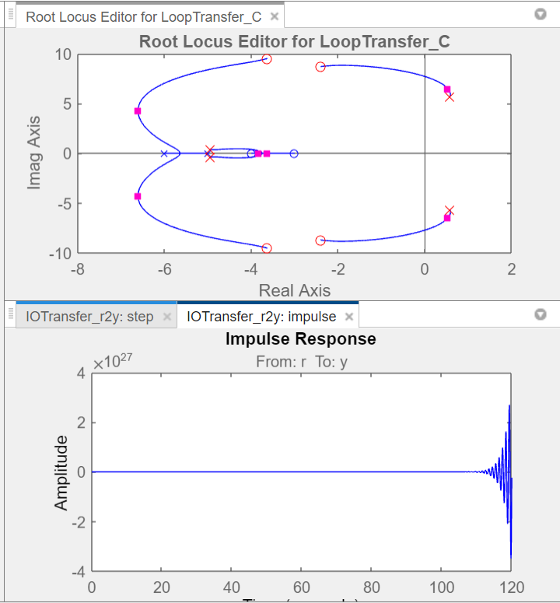

For k = 3

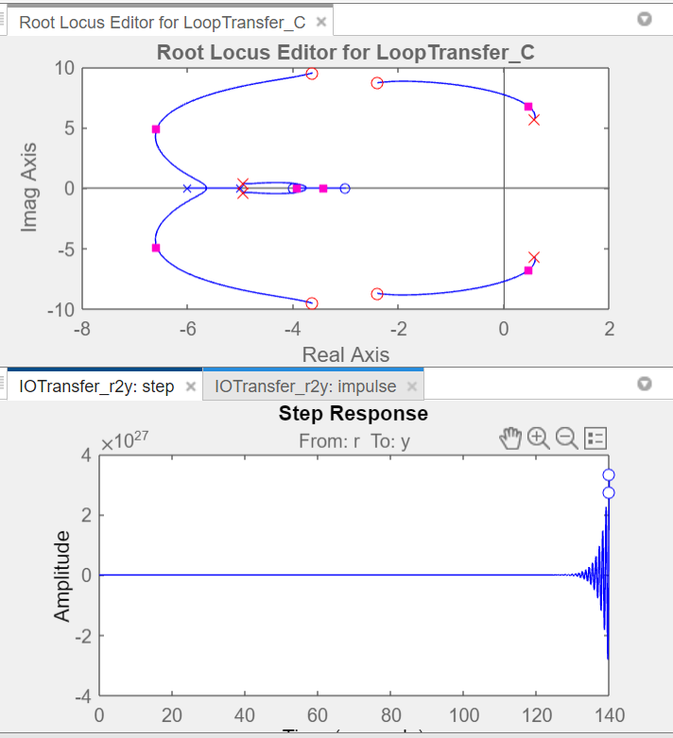

Unstable for k = 2 and 3